Integrated Programms

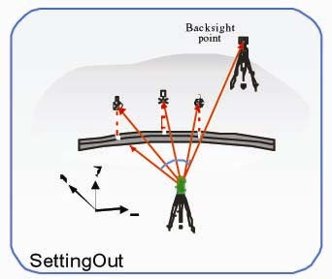
Normally it displays angle difference (dHR), and freely change to coordinate difference mode (dX, dY, dZ)

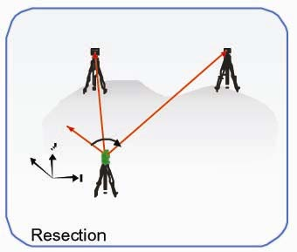
By setting up the instrument at an unknown point and measuring to at least two (max. five) known points, the coordinates of the instrument can be computed, the results are very reliable.

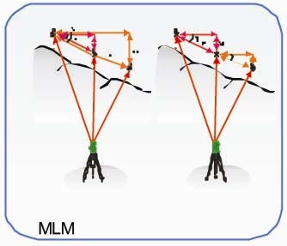
The horizontal distance, slope distance and height distance of reference point to any or two adjacent points can be easily measured.

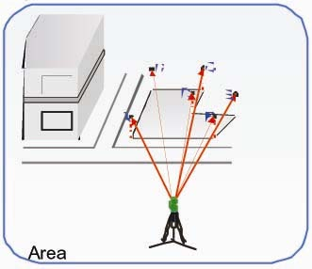
The object surface area is calculated and displayed as each target point is measured.

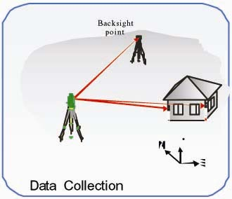
Various mode of data collection, point’s
data can be recorded as angle and slope
distance mode, or coordinate mode, or
horizontal distance and height difference
mode.

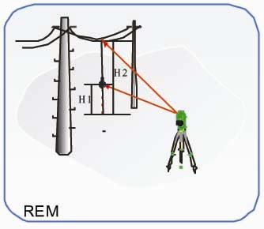
Two modes: with prism and without prism
can be selected, to measure the height of
point where a prism cannot be placed.

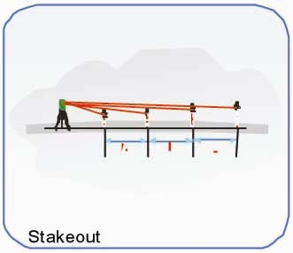
In road measurement, it is used for offset
of stake out. It can also be used to layout
of polar coordinates when the angle and
distance are known.

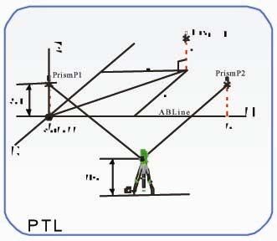
The Point to Line mode (PTL) is a method of interpretation of the point coordinates, the coordinates are defined from two known points, the line that through these points is set as one axis and it perpendicular as another.

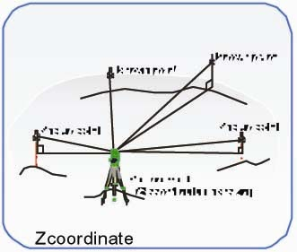
Measuring several known points (X,Y,Z) to calculate and reset Z coordinate of occupied point.

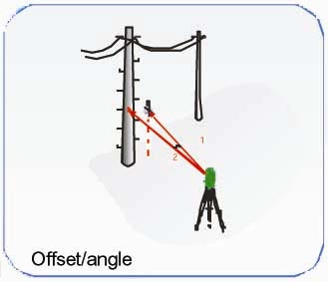
Any point which is difficult to set up the prism can be measured with this program. For example: center of tree, or a corner.

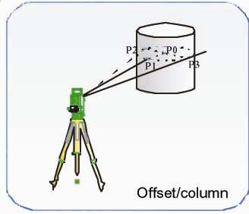
Measure circumscription point (P1) of column directly, the distance to the center of the column (P0), coordinate and direction angle can be calculated by measured circumscription points (P2) and (P3).
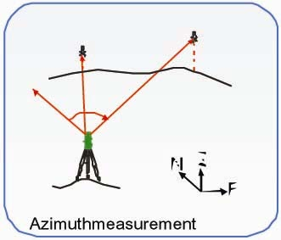
The azimuth angle from occupied point to unknown point can be measured conveniently.

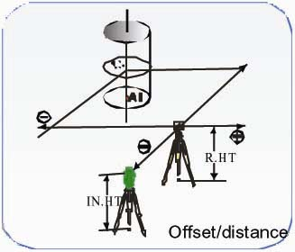
The measurement of a place apart from a prism is possible by inputting offset horizontal distance of front and back/right and left.

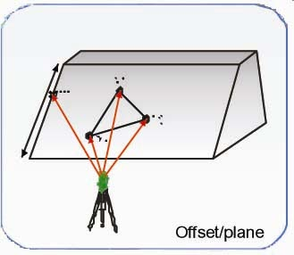
Three points (P1, P2, P3) on a plane will be measured at first to determine a plane. Collimating the measuring point (P0), the instrument calculates and displays coordinates and distance value of cross point between the collimation axis and of the plane.

Road Alignment Professional Software

Road design and edit
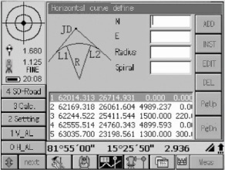 | 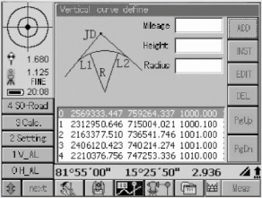 | 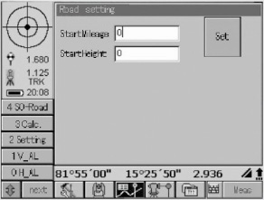
Road Design
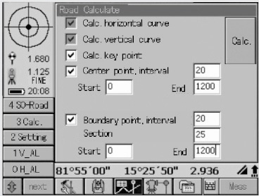 | Auto calculates horizontal and vertical alignment elements and road points by parameter settings of the road.
Road Layout
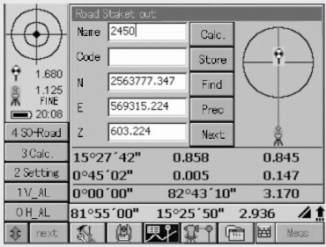 | Easy making road setout and guide by graphics

Topographic Survey Professional Software

Mapping in the field
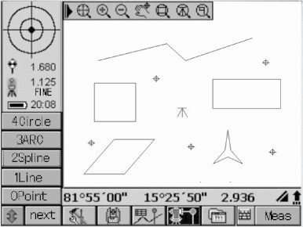
Real time mapping
The drawing can be saved as DXF file

